**Robust Variational Autoencoder**

**[DS-595 Fall 2018– ST: Unsupervised Learning]**

**Groups 4 & 8:**

Gao, Hongjian | Ren, Huimin | Singhal, Ishaan | Du, Xiao | Yue, Yun

[Worcester Polytechnic Institute]

Submitted on: 12/05/2018

**Table of Contents**

1. Introduction 3

1.1 Motivation 3

1.2 Objective 4

1.3 Dataset 4

2. Background 5

2.1 Introduction of Robust Principal Component Analysis 5

2.2 Introduction of Autoencoder / Variational Autoencoder 6

2.3 Introduction of Robust Deep Autoencoder (RDA) 7

2.4 Introduction of Deep Convolutional Generative Adversarial Network (DCGAN) 9

3. Methodology 10

3.1 Robust Variational Autoencoder 10

3.2 Robust PCA + Variational Autoencoder 12

3.3 Deep Convolutional Generative Adversarial Network 12

3.3.1 Discriminator network 12

3.3.2 Generator network 13

3.3.3 DCGAN model structure 13

3.3.4 Batch Size: 13

4. Numerical Results 13

4.1 Result of Robust Variational Autoencoder 14

4.2 Result of Robust PCA + Variational Autoencoder 19

4.3 Result of Deep Convolutional Generative Adversarial Network 20

4.4 Comparison with PCA 22

5. Conclusion 23

6. References 24

# 1. Introduction

The phenomenon of *Robust Principal Component Analysis (RPCA)* was introduced in December 17, 2009 by four mathematicians, Emmanuel J. Candès, Xiaodong Li, Yi Ma, and John Wright (Candès, Li and Ma). The main goal behind the research was to handle the problem of performing Principal Component Analysis (PCA) on grossly corrupted observations which were unavoidable in the real-world data.

In this study, the authors were trying to recover the components of a given data matrix which was comprised of a low-rank and a sparse matrix. They made use of a convex program called Principal Component Pursuit (PCP) where the algorithm targets minimizing the weighted combination of the nuclear norm of the low-rank matrix and the l1 norm of the sparse matrix.

An *autoencoder (AE)* (Wikipedia)is a type of artificial neural network *(ANN)* used to learn efficient data coding in an unsupervised manner. The aim of an autoencoder is to learn a representation (encoding) for a set of data, typically for dimensionality reduction. Recently, the autoencoder concept has become more widely used for learning generative models of data. *Variational autoencoder (VAE)* models inherit autoencoder architecture, but make strong assumptions concerning the distribution of latent variables.

*Artificial neural networks* (Wikipedia) or connectionist systems are computing systems vaguely inspired by the biological neural networks that constitute animal brains. The neural network itself is not an algorithm, but rather a framework for many different machine learning algorithms to work together and process complex data inputs. Such systems "learn" to perform tasks by considering examples, generally without being programmed with any task-specific rules.

Warren McCulloch and Walter Pitts(1943) created a computational model for neural networks based on mathematics and algorithms called threshold logic. This model paved the way for neural network research to split into two approaches. One approach focused on biological processes in the brain while the other focused on the application of neural networks to artificial intelligence. This work led to work on nerve networks and their link to finite automata.

## 1.1 Motivation

As noted by Zhou, C. and Paffenroth, R C in the paper, Anomaly Detection with Robust Deep Autoencoders (Zhou and Paffenroth), the deep autoencoders require a clean training dataset but, the real-world problems might not always have clean data handy for the algorithm. Due to this reason, we would like to explore the possibility of utilizing RPCA and Variational Autoencoders to denoise the data and generate new data using this.

## 1.2 Objective

As discussed above, the authors have combined RPCA and Deep Autoencoders to build a model called Robust Deep Autoencoders (RDA) (Zhou and Paffenroth) where the goal was to split the input data into two parts (one which can be reconstructed using deep autoencoders and other consisting of noise and outliers) and then used the denoised data for anomaly detection.

In our project we have taken a similar approach but, with a slight twist by combining RPCA and Variational Autoencoders, we call it Robust Variational Autoencoder (RVAE) to generate new image from a noisy data set. This replaces the auto encoder used in RDA with Variational Autoencoder. We have also reviewed the traditional RPCA + VAE algorithm and Deep Convolutional Generative Adversarial Network (DCGAN) algorithm for our study to compare the performances.

## 1.3 Dataset

We are working with the MNIST database of handwritten digits as our dataset (LeCun, Cortes and Burges). The MNIST database of handwritten digits, has a training set of 60,000 examples, and a test set of 10,000 examples. It is a subset of a larger set available from NIST. The digits have been size-normalized and centered in a fixed-size image.

For our analysis we picked 55,000 images for our training dataset as available in TensorFlow. We have added gaussian noise to our image dataset to simulate the noisy data. For our analysis, as discussed in detail in the later part, we have used 0.2 and 0.4 noise factor. 0.2 and 0.4 noise factor imply we have randomly corrupted 20% and 40% of pixels in the dataset. Below is the sample snapshot of the noisy input data we used for our training.

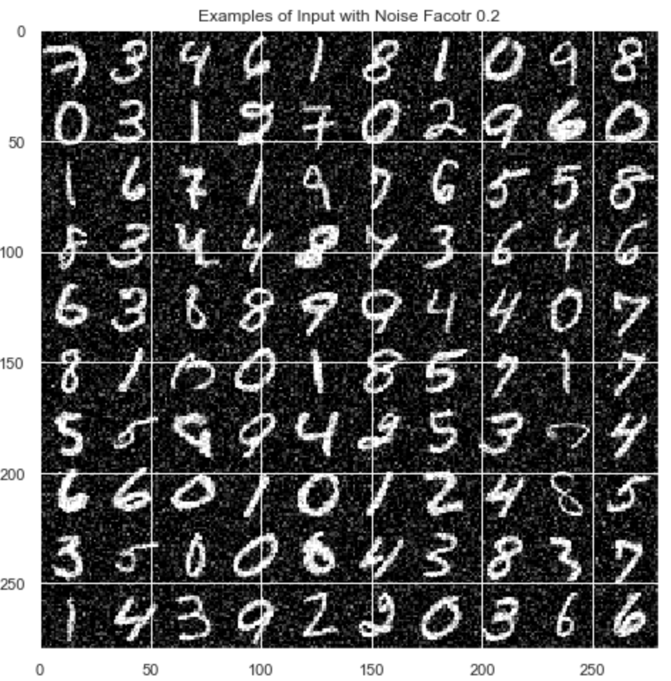 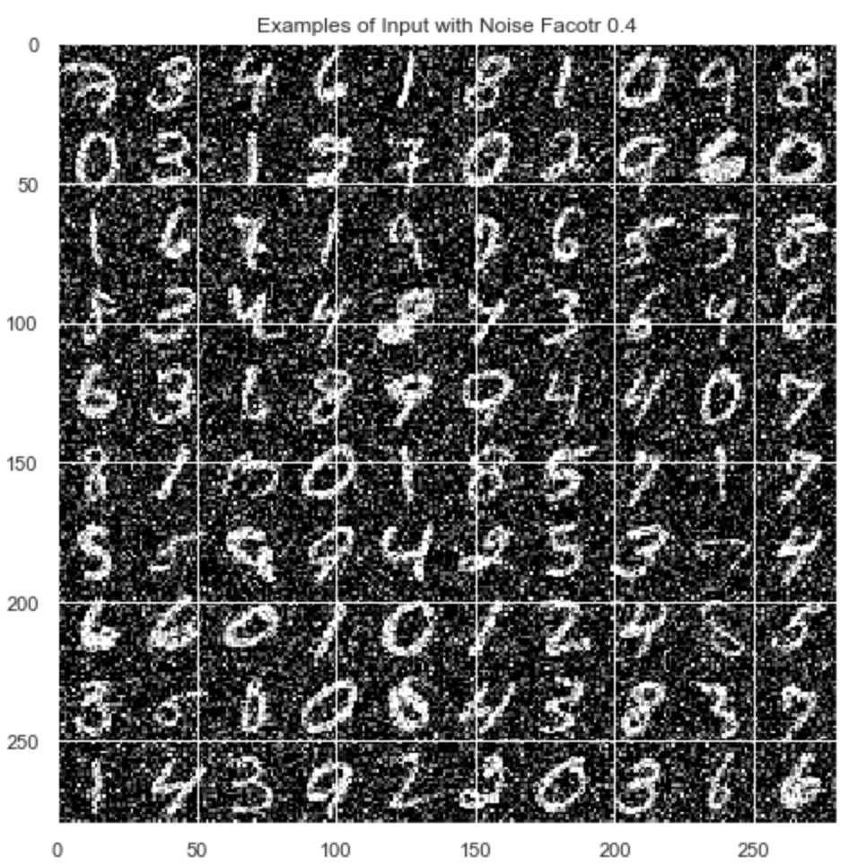

Figure 1.3.1 Examples of 20% noisy data Figure 1.3.2 Examples of 40% noisy data

# 2. Background

## 2.1 Introduction of Robust Principal Component Analysis

The phenomenon of Robust Principal Component Analysis (RPCA) was introduced in December 17, 2009 by four mathematicians, Emmanuel J. Candès, Xiaodong Li, Yi Ma, and John Wright (Candès, Li and Ma). The main goal behind the research was to handle the problem of performing Principal Component Analysis (PCA) on grossly corrupted observations which were unavoidable in the real-world data.

RPCA is a situation where we have a data matrix M which is comprised of an unknown low-rank matrix L0 and an unknown sparse matrix S0 and the goal is to recover both the matrices L0 and S0 accurately. And this problem can be solved using tractable convex optimization. Under weak assumptions, the Principal Component Pursuit (PCP) (Candès, Li and Ma) estimate the solving of the RPCA problem as follows:

If we have,

$$M=L_{0}+S_{0}$$

Where,

L0 = Unknown matrix with unknown rank

S0 = Unknown matrix with unknown number of entries that are not equal to zero and unknown location of these entries and unknown magnitudes

We can estimate that solving the below will give us the low-rank and sparse components.

$${minimize}_{L,S} rank\left(L\right)+λ{|\left|S|\right|}_{0},$$

$$such that M=L+S$$

Using convex relaxation, we know that the below would hold true,

$$minimiz{e }_{L,S} {|\left|L|\right|}_{*}+λ{|\left|S|\right|}_{1},$$

$$such that M=L+S$$

Where,

||L||*is nuclear norm (sum of non-zero singular values) =>

||S||1 is entry-wise l1 norm (sum of non-zero entries in S) => ${\left||S|\right|}_{1}=\sum_{ij}{|S_{ij}|}$

λ > 0 is a regularization parameter to balance the terms

Solving above formulas would exactly recover low-rank L0 and sparse S0.  
This is theoretically guaranteed to work if the rank of L0 grows almost linearly in the dimension of the matrix and errors in S0 are up to a constant fraction of all entries. The authors also show in the original paper that algorithmically, the solution of this is efficient and scalable and doesn’t cost much more than classical PCA.

## 2.2 Introduction of Autoencoder / Variational Autoencoder

Autoencoder is an unsupervised learning algorithm with neural network structure. The purpose of Autoencoder is to reconstruct X when the data X go through a bottleneck of the neural network.

Mapping from input X to hidden layer can be expressed as

$$E(X) = g(a(X)$$

$=sigm(b+WX)$

This is called encoder with $sigm$ is Sigmoid function people usually use. W is the weight matrix connecting input and hidden layer, $b$ is the bias term. Correspondingly, the decoder is

$$D(E(X) = o(\hat{a}(x))$$

$=sigm(c+W*h(X))$

Decoder is also a linear transformation of latent representation passing into a non-linear function (sigmoid here). Say $\hat{X}$ is the reconstructed data, the objective of Autoencoder is $X$ should be similar to $\hat{X}$. If there is only one hidden layer without activation function, Autoencoder model is identical to PCA. When we add non-linearity layers, autoencoder becomes deep autoencoder. Figure 2.2.1 shows the structure of deep autoencoder.

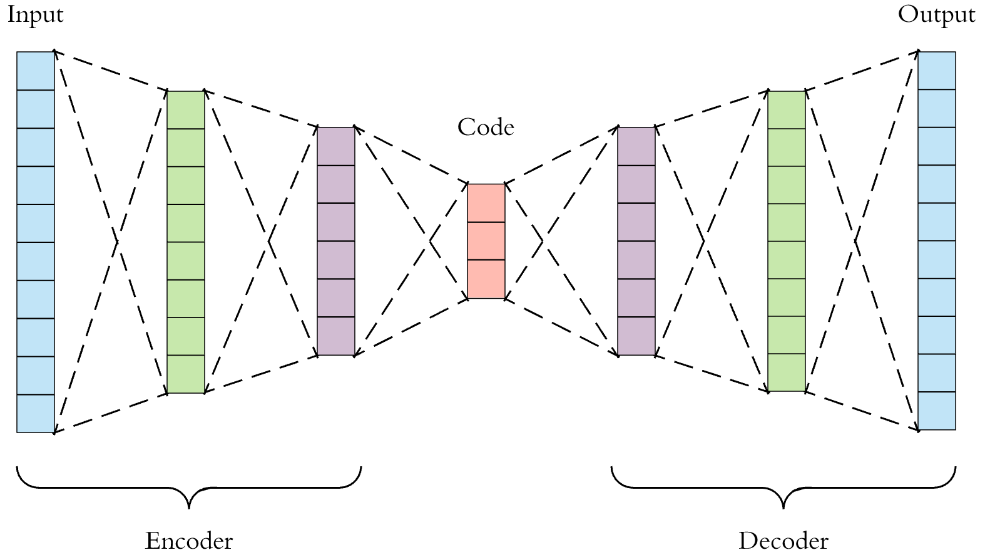

Figure 2.2.1 Illustration of Deep Autoencoder (Dertat)

Similar to Autoencoder, Variational Autoencoder is also an unsupervised learning algorithm but used for generation. Different with the traditional Autoencoders, the representations $z$ is sampled from Gaussian distribution. Thus, the encoder layers of VAE output two vectors, a vector of means, μ and a vector of standard deviations, 𝜎. Then the representations $z$ sampled from this Gaussian distribution $N(μ,δ)$, which can be expressed as,

$$z = exp(δ)×e+μ$$

What the decoder layers of VAE do is the same as Autoencoders, reconstructing the latent representation layer to the original input. Except for minimizing the reconstruction error, VAE also needs to minimize the Kullback-Leibler (KL) divergence to learn how to generate new images. Figure 2.2.2 shows the structure of VAE.

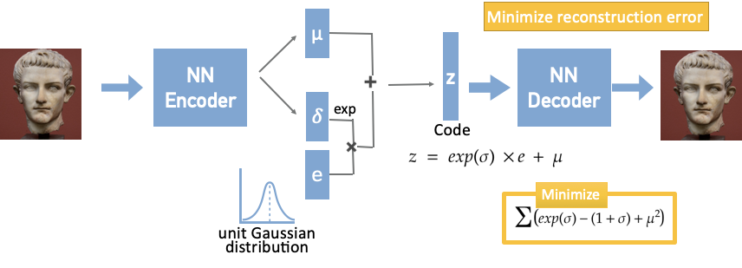

Figure 2.2.2 Illustration of Variational Autoencoders

## 

## 2.3 Introduction of Robust Deep Autoencoder (RDA)

In the KDD 2017 conference, Zhou, Chong and Paffenroth, Randy C presented their study on the topic Robust Deep Autoencoder (RDA) (Zhou and Paffenroth). This model is designed to maintain the deep encoder’s ability to discover high quality non-linear features in the data but, also use the principles of RPCA to remove outliers and noise from the data. The authors of the paper used this algorithm for anomaly detection in data.

Autoencoders are a type of neural network where the data is projected to a lower dimensional space and then attempts to retrieve the data back to its original dimension. The projections here can be non-linear. This can be denoted as follows:

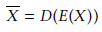

Where,

X - Input data

E - encoding map form input data to hidden layer

D - decoding map from hidden layer to output layer

- recovered version of input data

The goal is to reduce the difference between X and $\overline{X}$ by training E and D. This can be viewed as:

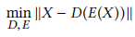

Where,

|| . || is chosen to be l2-norm

The RPCA algorithm is already discussed in section 2.1 above. The goal is to split the given data into sparse outliers and low-rank data. After convex relaxation we have,

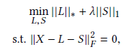

The authors combined them to present the optimization as:

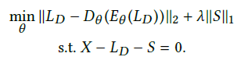

Where E and D are as follows,

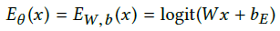



RDA, as studied in the paper, had better error rates than traditional DAE in the red regions and vice versa in blue regions. Error rates are computed based on the prediction of image labels with respect to changing value of $λ$ and degrees of corruption.

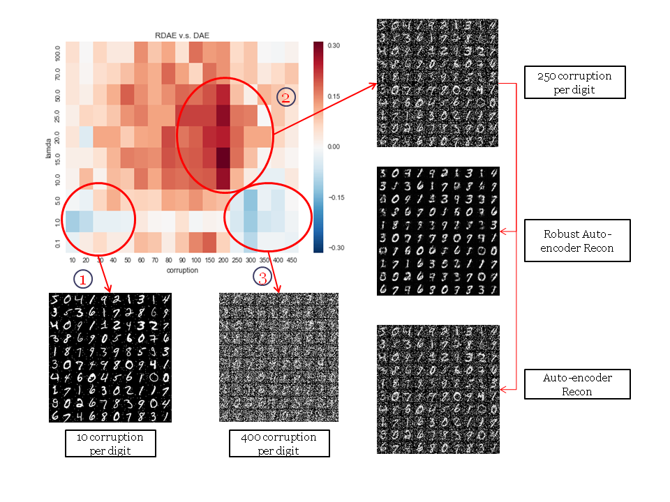

Figure 2.3.1 The difference between error rates for the features constructed by autoencoder and RDA

The remainder of the paper speaks about the detection of anomalies in the data. We have not made use of the algorithm for anomaly detection in our study but, the paper does talk about the detection of anomalies with higher accuracy.

## 2.4 Introduction of Deep Convolutional Generative Adversarial Network (DCGAN)

Before we talk about DCGAN, we will briefly explain Generative Adversarial Networks (GAN). The original GAN is an unsupervised learning method that subtly uses the "confrontation" idea to learn the generative model and generate new data samples once the training is complete. DCGAN (Radford, Metz and Chintala) extends the concept of GAN into a convolutional neural network to generate high quality image samples.

The principle of GAN is actually very simple. GAN can be regarded as a data generation tool. Here is an example of generating image data. The actual GAN can be applied to any type of data.

Suppose there are two networks, generator network G (Generator) and discriminator network D (Discriminator).

Their functions are:

* G is responsible for generating a picture, which receives a random noise z, generates a picture from the noise, and records the generated picture as G(z).
* D is responsible for determining whether a picture is "real". Its input x, x represents a picture, and the output D(x) represents the probability that x is a real picture.

In the training process, the goal of generator network G is to generate a real picture as much as possible to deceive the discriminator network D, and the goal of D is to distinguish the generated picture from the real picture as much as possible. Thus, G and D constitute a dynamic "game", which is the basic idea of GAN.

The full name of DCGAN is Deep Convolutional Generative Adversarial Networks, which was proposed by Alec Radford in the paper Unsupervised Representation Learning with Deep Convolutional Generative Adversarial Networks. From the name point of view, it is based on the GAN to add a deep convolutional network structure, specifically generated image samples.

In fact, GAN does not impose any restrictions on the specific structure of D and G. The meanings and losses of D and G in DCGAN are exactly the same as those in the original GAN, but it adopts a special structure in D and G to effectively model the picture.

For discriminator D, the input is an image and the output is a probability of the image being a real image. In DCGAN, the structure of discriminator D is a convolutional neural network. The input image is convolved through several layers to obtain a convolution feature. The obtained feature is sent to the Logistic function, and the output can be regarded as probability.

In addition, G, D has some other implementation details:

* Instead of using any Pooling Layer, in Discriminator D, a convolution with a Stride is used instead of the pooling layer.
* Use Batch Normalization in both G and D to help the model converge.
* In G, the activation function uses the ReLU function except for the last layer, while the last layer uses the tanh function.
* In D, the activation function uses Leaky ReLU as the activation function.

# 3. Methodology

In this project , we compared three different methods to remove noise and generate new images. The first one was to replace Autoencoder with Variational Autoencoder in Robust Deep Autoencoder (Zhou and Paffenroth). Second, we used RPCA to remove the noise and then implement Variational Autoencoder to generate new images. And the last model we used was DCGAN (Radford, Metz and Chintala) which can generate new images from noise image directly.

## 3.1 Robust Variational Autoencoder

The central idea of RDA is to inherit the non-linear representation ability of Autoencoder and anomaly detection ability of RPCA to construct denoising Autoencoder. In our model, we would like to take advantage of RDA and data reconstruction ability of Variational Autoencoder. Our proposed data generating model aims at emphasizing the research gap when there is no clean, noise-free data available, how do we generate new data in the similar distribution of denoising data.

Since RDA has emphasized on denoising autoencoder with noise data, we would just replace the autoencoder part in Zhou and Paffenroth, 2017 (Zhou and Paffenroth) with variational autoencoder. We name our method as Robust Variational Autoencoder (RVAE). In order to demonstrate the ability of process non-clean data of our model, we added Gaussian noise on purpose to MNIST data. There are two different noise setting in our experiments. With noise factor setting to 0.2 and 0.4 we are able to corrupt the MNIST data with 20% and 40% Gaussian noise respectively. We use the same noisy data in all the experiments in this paper. Our purpose is to represent the true data with a low rank matrix while isolate outliers with a column sparse matrix before we reconstruct the data. In the work of Zhou and Paffenroth, 2017 (Zhou and Paffenroth), they defined a scale $λ$ in their optimization function. This value tuned to control the amount of data to be isolated as noise or outliers. The smaller the $λ$, the more data are isolated as noise or outliers. In our experiment, we tried $λ$ with the different values (1, 10, 100, 500, 1000, 2000, 3000) in our model.

Following the work of Zhou and Paffenroth, 2017 (Zhou and Paffenroth), we implemented three different structures of RVAE. The implementation of RVAE 1 is illustrated in Figure 3.1.1, which has three hidden layers with 512, 384, 256 neurons respectively and 1 latent layer with 5 neurons. All the layers are fully connected with elu activation function. RVAE 2 is very similar to what we are showing in Figure 3.1.1. Instead of setting 5 neurons in latent layer as in RVAE 1, we used 49 neurons in latent layer for RVAE 2. As for RVAE 3, we implemented the same structure as RVAE 1 but replaced elu activation function to sigmoid activation function for all the dense layers.

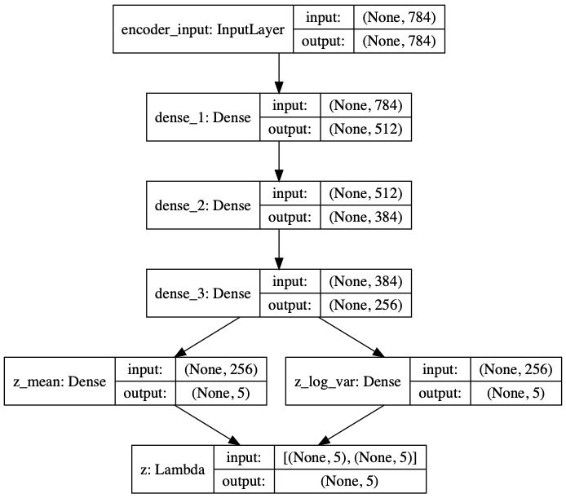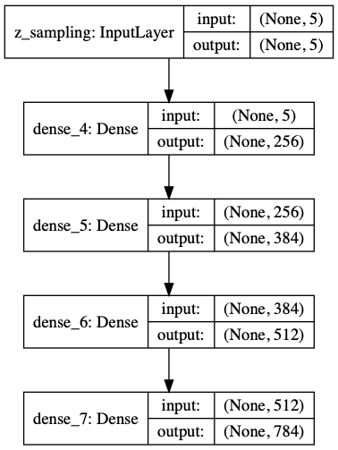

Figure 3.1.1 Structure of RVAE 1 (Sun)

## 3.2 Robust PCA + Variational Autoencoder

We employ the RPCA algorithm (Candès, Li and Ma) here to split the noisy data into Low Rank Denoised Matrix and Sparse Matrix with the noise. As explained earlier in 2.1, our goal is to:

minimize L,S ||L||* + λ||S||1,

such that M = L + S

where,

||L||* is nuclear norm (sum of non-zero singular values) =>

||S||1 is entry-wise l1 norm (sum of non-zero entries in S) => ${\left||S|\right|}_{1}=\sum_{ij}{|S_{ij}|}$

λ > 0 is a regularization parameter to balance the terms

Solving above would exactly recover low-rank L0 and sparse S0.

Once we have recovered the low-rank denoised matrix, we run the variational autoencoder structure (VAE1) (Sun) as explained in section 3.1. The reason for choosing only VAE1 structure for our analysis was because the results obtained were satisfactory for our project purposes.

Finally, we compare the images generated using this methodology with other models in the Numerical results section.

## 3.3 Deep Convolutional Generative Adversarial Network

We are going to use a TensorFlow variable scope when defining this network. This helps us in the training process later, so we can reuse our variable names for both the discriminator and the generator.

### 3.3.1 Discriminator network

The discriminator network consists of three convolutional layers, opposed to four layers in the original architecture. We remove this last layer to simplify the model a little bit. This way, the training goes a lot faster without losing too much quality. This makes training go a little bit faster. For every layer of the network, we are going to perform a convolution, then we are going to perform batch normalization to make the network faster and more accurate, and, finally, we are going to perform a Tanh to further speed up the training. At the end, we flatten the output of the last layer and use the sigmoid activation function to get a classification. We now have a prediction whether the image is real or not.

### 3.3.2 Generator network

The generator goes the other way: It is the “artist” who is trying to fool the discriminator. The generator makes use of deconvolutional layers. They are the exact opposite of a convolutional layers: Instead of performing convolutions until the image is transformed into simple numerical data, such as a classification, we perform deconvolutions to transform numerical data into an image. This is a concept which is not as known as a simple convolutional layer, since it’s used for advanced topics. We are wrapping this in a variable scope as well, just as we did in the discriminator network. Here, we are doing the same thing as the discriminator, just in the other direction. First, we take our input a random array, and feed it into our first deconvolutional layer. Each deconvolutional layer performs a deconvolution and then performs batch normalization and a leaky Tanh as well. Then, we return the tanh activation function in the end.

### 3.3.3 DCGAN model structure

Compile discriminator and generator. For loss function: binary cross entropy, and for optimizer we choose the Adam optimizers. For Adam optimizers is an extension to stochastic gradient descent that has recently seen broader adoption for deep learning applications in computer vision and natural language processing.

#### 3.3.3.1 Generator model structure:

Generate a single 28 x 28 x 1 image from 100 units.

{z1,z2….z100}(-1 ⥶ z ⥶ 1) → reshape layer →16x(7x7) → 4x(14x14)→ 1x(28x28)

#### 3.3.3.2 Discriminator model structure:

Calculate a probability that a single 28 x 28 x 1 image is authentic.

1 x (28x28)→ 4x(14x14) →16x(7x7) → dense layer: Probability of authentic image

### 3.3.4 Batch Size:

Our batch size is 100, which means modify filter parameters using 100 generated images and 100 Flower images at a time.

# 4. Numerical Results

In this section, we compared the quality of generative images by using MNIST dataset (LeCun, Cortes and Burges) with three methods, RVAE, RPCA+VAE and DCGAN. The training set consists of 55,000 instances and each instance is a 28*28-pixel image with some Gaussian noise.

## 4.1 Result of Robust Variational Autoencoder

We implemented RVAE using TensorFlow, version 1.11.0 (TensorFlow). We ran our experiments on Turing server (WPI) with 16 GPUs and 32 GB memory. As we mentioned in section 3.2, there were three structures of VAE. For all the structures, we used the same learning rate which is 1e-3 and batch size equals to 256 and 30 epochs but different $λ$ with 1, 10, 100, 500, 1000, 2000 and 3000 to train the model. For our experimentation, we generated multiple images for each structure of VAE by varying the values of $λ$ and noise factor.

Compared with different generative images, we found that RVAE 3 had the best performance in two noise factor settings with $λ=100$. Figure 4.1.1 shows the loss of all three structures with noise factor equal to 0.2 and 0.4, respectively. As the training epochs increased, all the loss decreased. However, after 15 iterations, we noticed that there was a gap in RVAE 2 with 20% noise. At this point, we do not have a good explanation about of this gap yet.

Figure 4.1.2 and 4.1.3 show the loss changes when $λ=1$ and $λ=1000$ respectively. From our understanding, when $λ=0$, RVAE is simply VAE since everything is treated as the input data for learning for image generation (i.e. data with noise). As noticed in the RDA paper, a small value of $λ$ would encourage much of the data to be isolated as noise. At $λ=1$, a large part of the data would be treated as noise and the learning for the image generation would be completely random. For larger values of $λ$, very little noise is removed from the input data. This leads to worse results (image with noise) in image generation. The value of the $λ$ has to be somewhere in the middle where the image generation gives us best results. From our experimentation, we found it to be closer to 100.

From Figure 4.1.2, we can see the loss didn’t converge with the training step increased. Which means the more we train the model trained, the worse the images generated. Figure 4.1.4 and 4.1.5 show the examples of the generation when $λ=1$ of RVAE 1 with 40% noise.

Although the loss didn’t decrease very much when $λ=2000$ in Figure 4.1.3, and there were gaps in RVAE 1 and RVAE 2, the generation was not as bad as what happened when $λ=1$. And probably because of the gap, RVAE 1 and RVAE 2 generated blank images after 11 epochs and 19 epochs respectively and we are unsure for the reason. Figure 4.1.6 and 4.1.7 show the examples of generation when $λ=2000$ of RVAE 2 with 20% noise. Compared with Figure 4.1.5, the generation in 4.1.7 were much better.

Our best generation was when $λ=100$. From the loss plot, it looks like RVE 2 had the best performance. However, we found the generation of RVE 3 was the best when evaluated by visual inspection in both noise factors. Figure 4.1.8 and 4.1.9 show the generation at the first epoch and the last epoch of RVAE 3 when $λ=100$ with 20% noise, which we can see an obvious progress. Figure 4.1.10 shows the generation of RVAE 2 at the last epoch with 20% noise, which is less sharp as compared with Figure 4.1.9.

To our surprise, RVAE 3 also worked very well with 40% noise. Figure 4.1.11 and 4.1.12 show the examples of generation. In later section, we will also show the generation of RPCA+VAE and DCGAN. All the generation of these two models didn’t work very well.

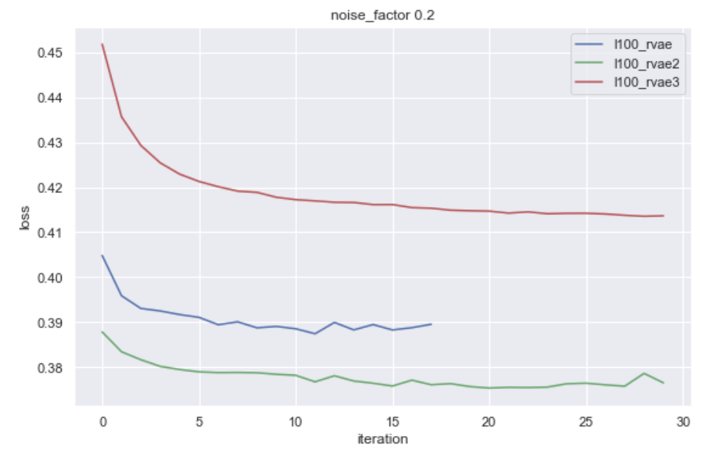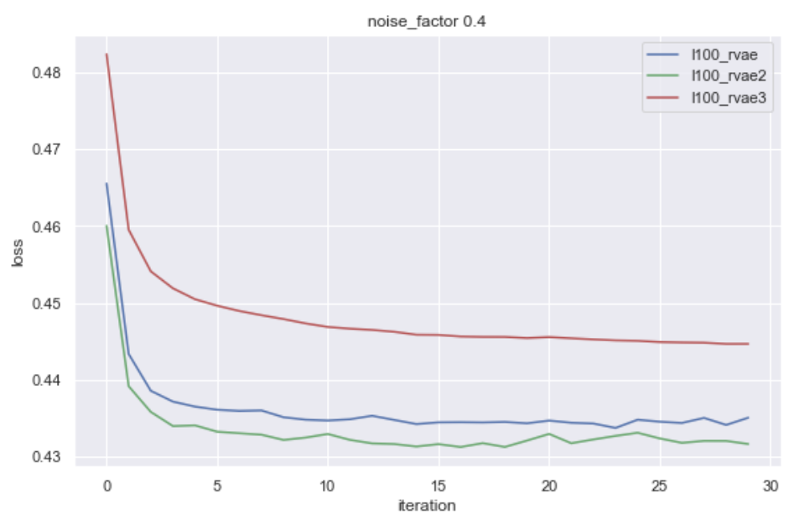

Figure 4.1.1 Loss of RVAEs when $λ=100$

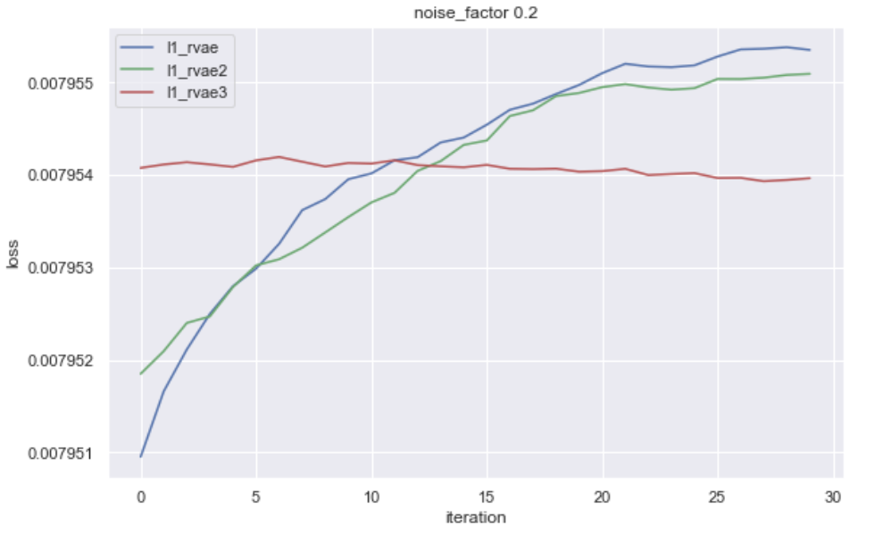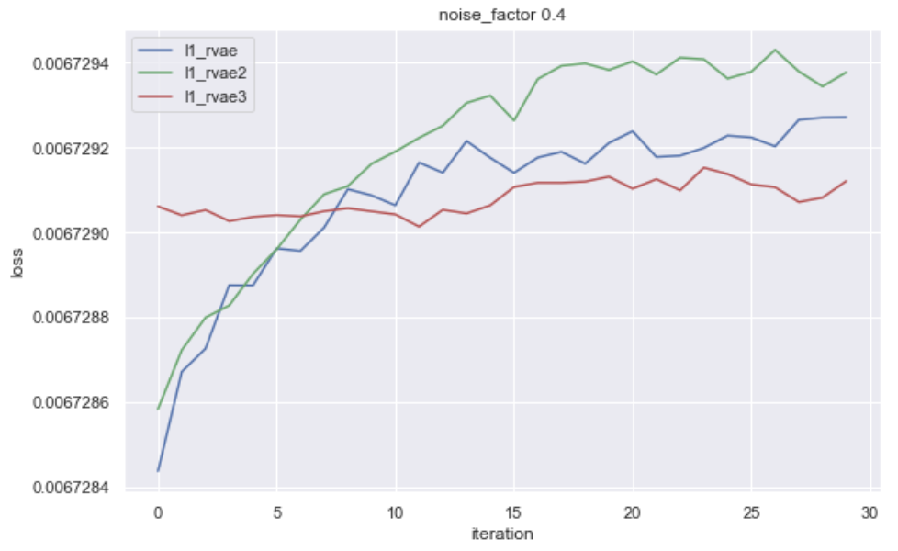

Figure 4.1.2 Loss of RVAEs when $λ$ = 1

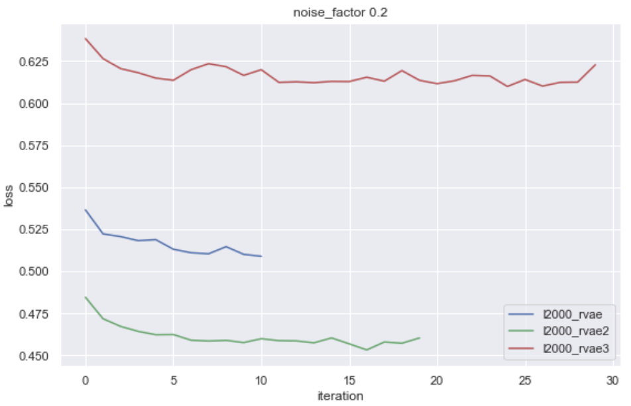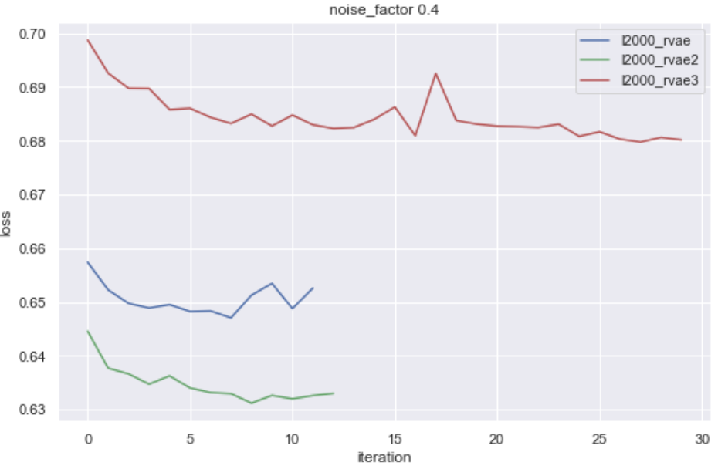

Figure 4.1.3 Loss of RVAEs when $λ$ = 2000

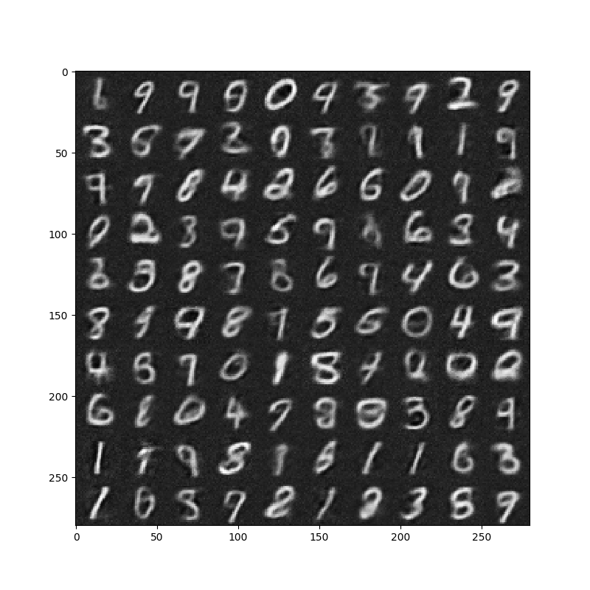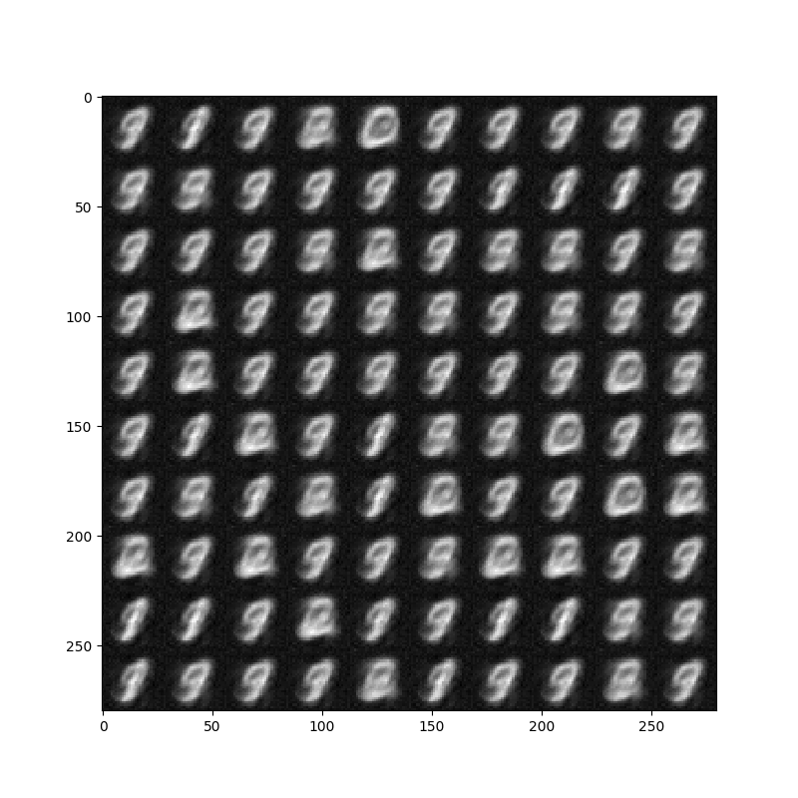

Figure 4.1.4 Generation of RVAE1 at epoch 1 at noise 0.4 Figure 4.1.5 Generation of RVAE1 at epoch 30 at noise 0.4

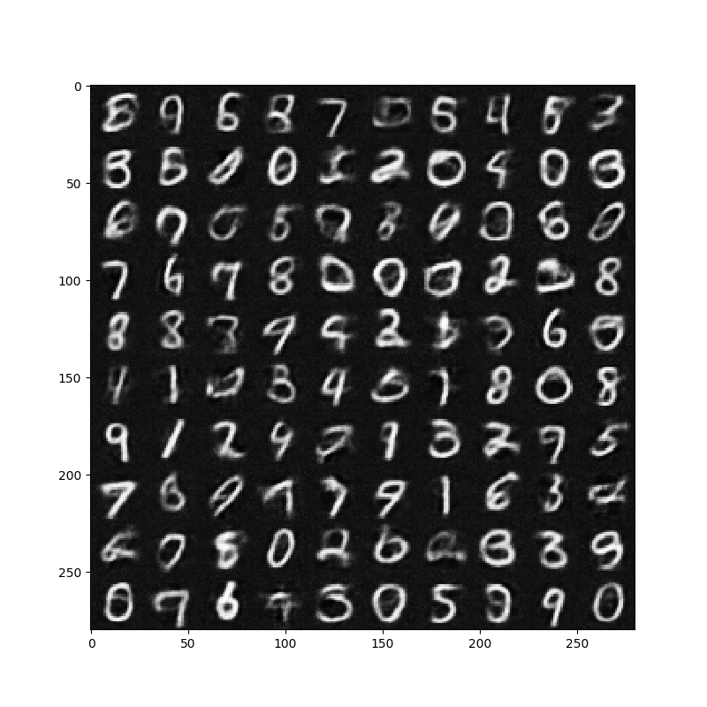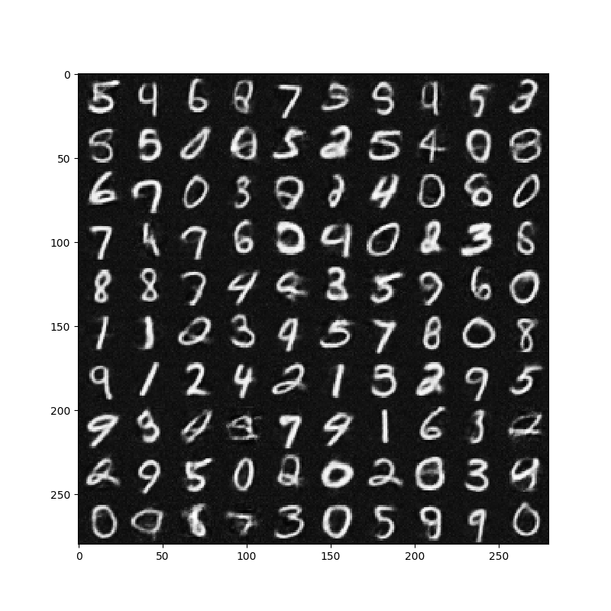 Figure 4.1.6 Generation of RVAE2 at epoch 1 at noise 0.2 Figure 4.1.7 Generation of RVAE2 at epoch 30 at noise 0.2

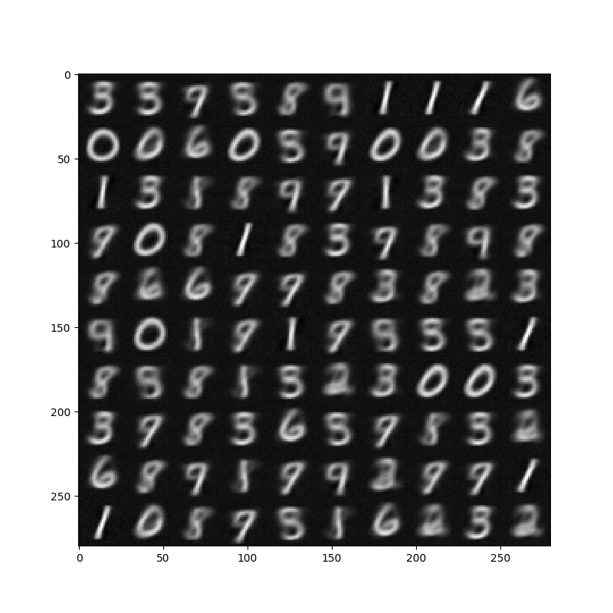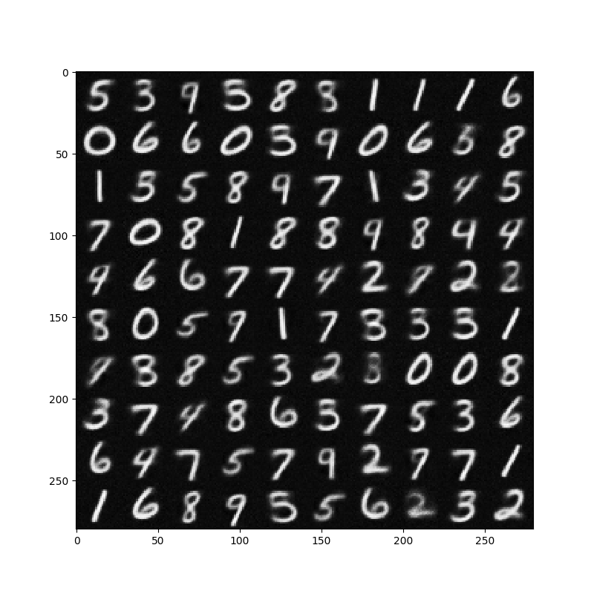

Figure 4.1.8 Generation of RVAE3 at epoch 1 at noise 0.2 Figure 4.1.9 Generation of RVAE3 at epoch 30 at noise 0.2

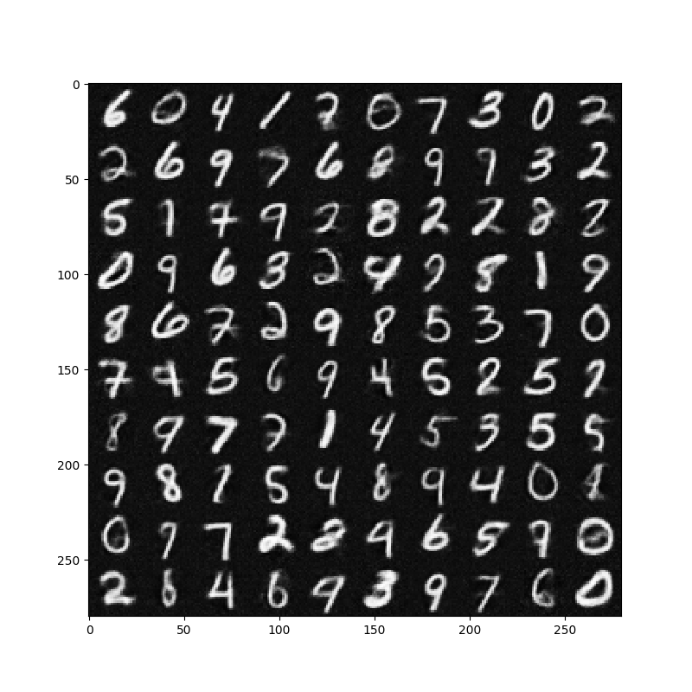

Figure 4.1.10 Generation of RVAE2 at epoch 1 at noise 0.2 Figure 4.1.9 Generation of RVAE3 at epoch 30 at noise 0.2

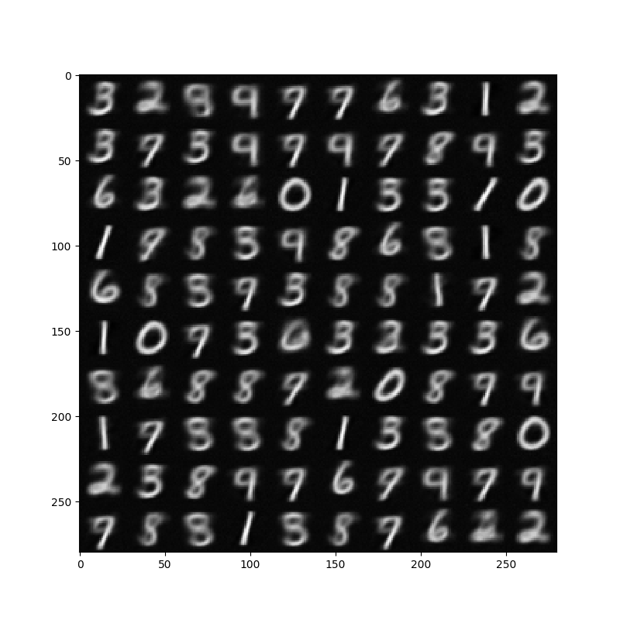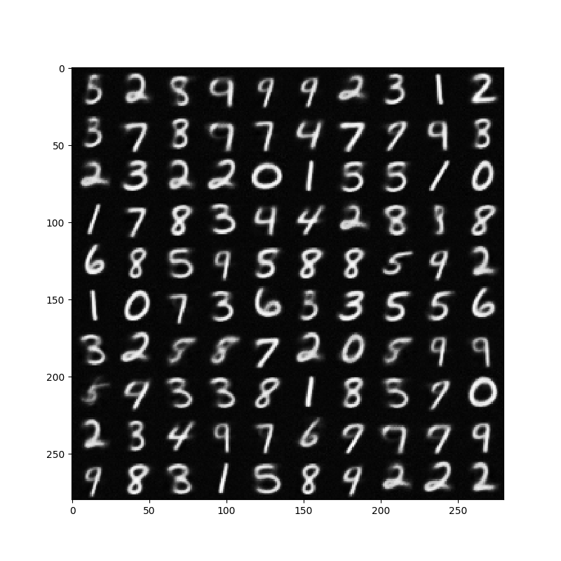

Figure 4.1.11 Generation of RVAE3 at epoch 1 at noise 0.4 Figure 4.1.12 Generation of RVAE3 at epoch 30 at noise 0.4

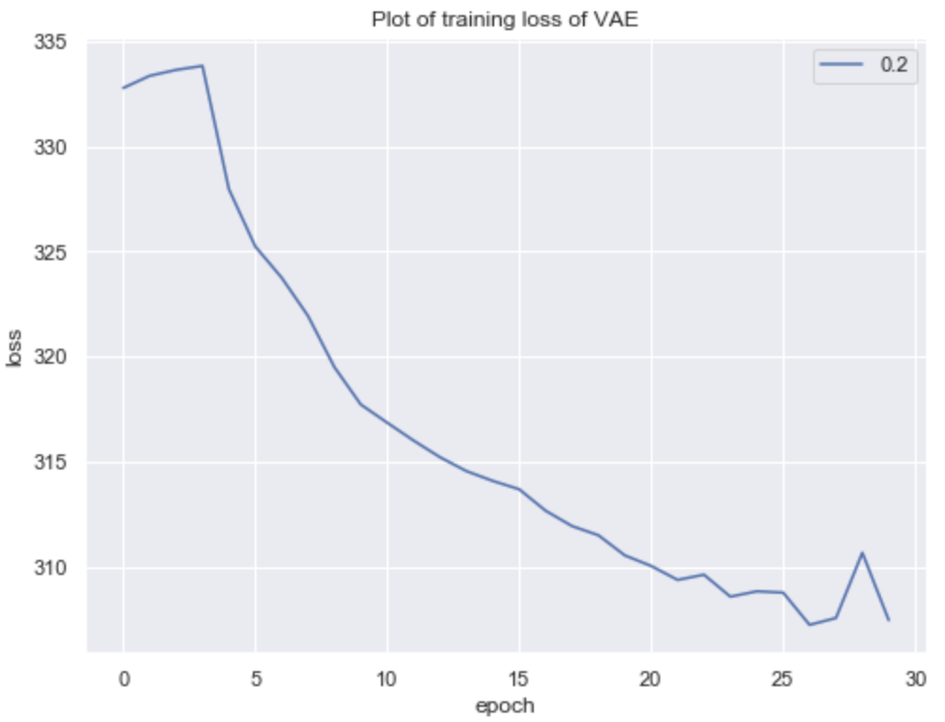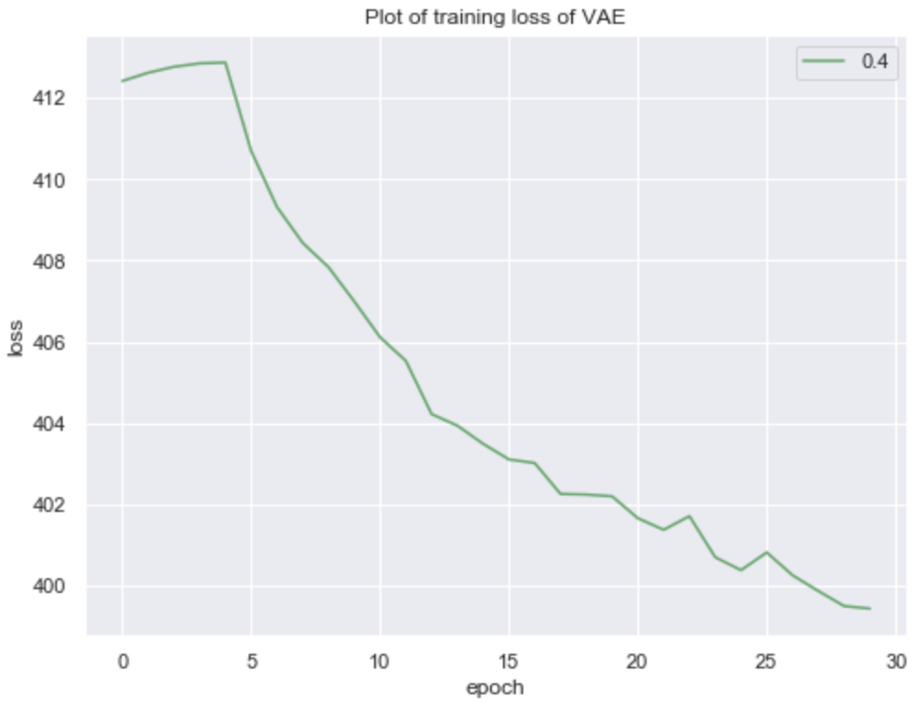

Figure 4.1.13 Loss of VAE at noise 0.2 Figure 4.1.14 Loss of VAE at noise 0.4

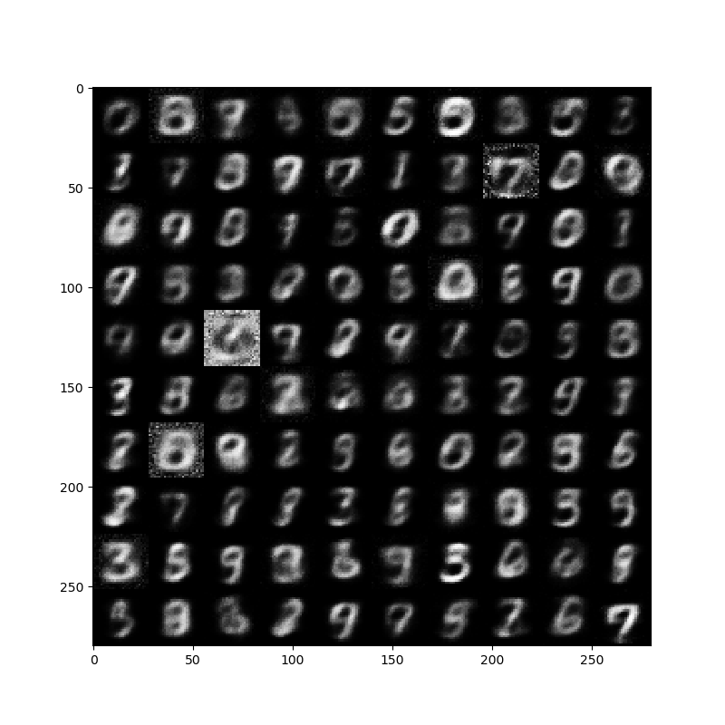 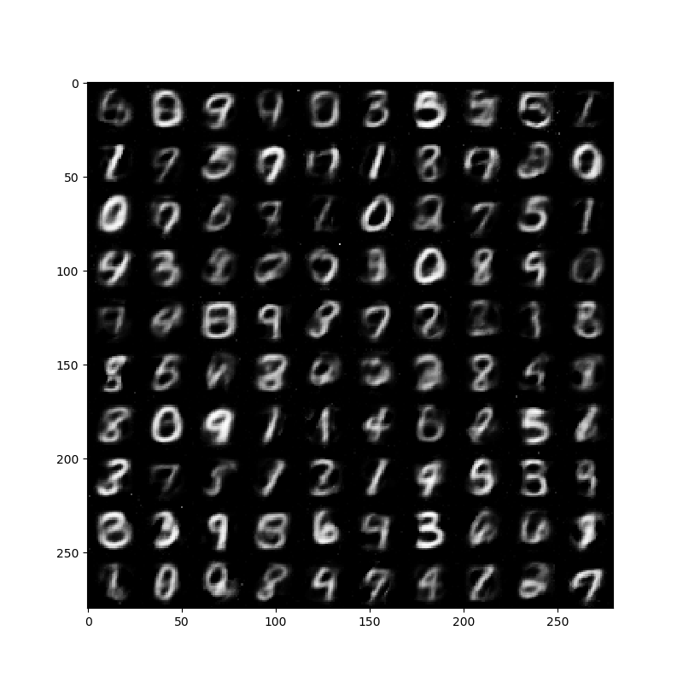

Figure 4.1.15 Generation of VAE at epoch 1 at noise 0.2 Figure 4.1.16 Generation of VAE at epoch 30 at noise 0.2

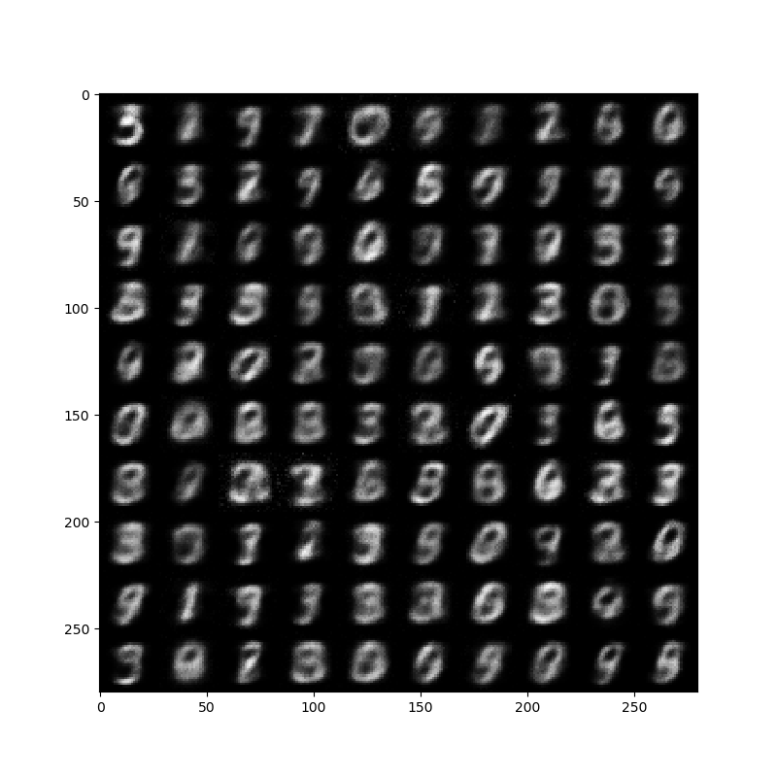 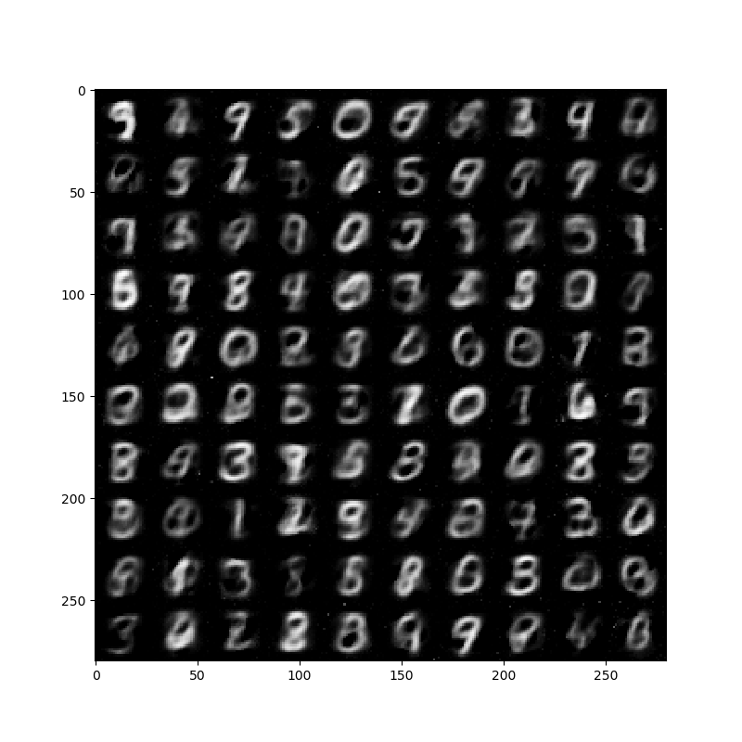

Figure 4.1.17 Generation of VAE at epoch 1 at noise 0.4 Figure 4.1.18 Generation of VAE at epoch 30 at noise 0.4

At the end of the experiment of RVAE, we implemented VAE with the corrupted images of 20% and 40% Gaussian noise without any denosing. The structure and parameter of VAE is the same as VAE in RVAE 3 since it is our best model to generate images. From figure 4.1.13 and 4.1.14, the loss plot of VAE look good at both noise factor 0.2 and 0.4. We generated multiple images of VAE at noise factor 0.2 and 0.4. Figure 4.1.16 and Figure 4.1.18 show the generative images from VAE. All of them look blurrier than what we generated from RVAE.

## 

## 4.2 Result of Robust PCA + Variational Autoencoder

Here we used the same input data as before and ran the model through the RPCA algorithm for each of 0.2 and 0.4 noise factors. Upon completion of this, we ran the VAE1 algorithm as explained in section 3.1.

You can notice below the outcomes from the first and the last epoch for each of the noise factors. Upon side-by-side comparison with RVAE, DCGAN, and this, we noticed that the generated images were better than DCGAN but less sharp as compared to RVAE.

Noise factor 0.2:

 

Figure 4.2.1 Generation of RPCA+VAE at first epoch at noise 0.2 Figure 4.2.2 Generation of RPCA+VAE at last epoch at noise 0.2

Noise factor 0.4:

 

Figure 4.2.3 Generation of RPCA+VAE at first epoch at noise 0.4 Figure 4.2.4 Generation of RPCA+VAE at last epoch at noise 0.4

## 4.3 Result of Deep Convolutional Generative Adversarial Network

Here is our train process for our project: we changed the learning rate for not only the discriminator but also the generator for difference combinations. Ideally, we would like the discriminator to be as good as possible in order to force the generator to capture the true data distribution. But we would also like the generator to be able to learn correctly. Meanwhile, try to generate graphs with different noise factors. For this reason, we have tried different values for the balancing, but we always imposed a higher value for the discriminator over the generator.

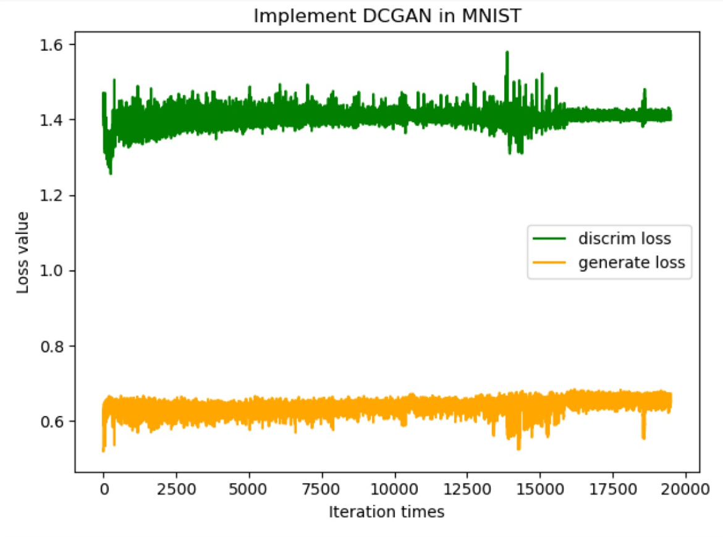 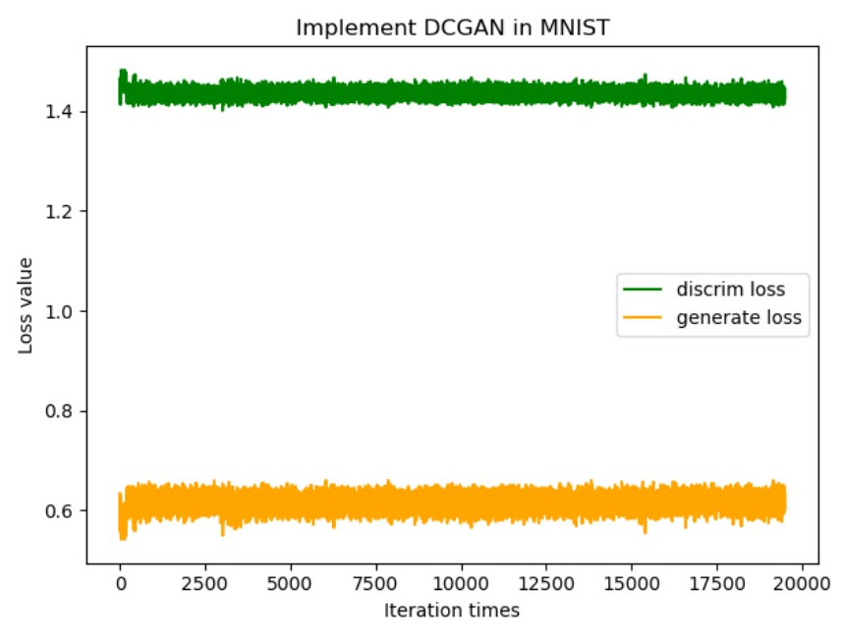

Figure 4.3.1 Loss of DCGAN at noise 0.2 Figure 4.3.1 Loss of DCGAN at noise 0.4

Figure 4.3.1: the loss value for generator and discriminator in the all iterations, the learning rate combination D/G = 0.0002/0.0002 is the best hyper parameter among the three combination.

Now, we just got our inputs, losses, and optimizers which we defined before, called a TensorFlow session and ran it batch per batch. Every 100 batches, we were printing out the current progress by showing the generated image and the generator and discriminator loss. Now lean back and see the digits show up slowly but steady. This progress can take up to an hour or more, based on the setup. In the end, we compared the graphs generated in epoch(1, 2,5, 20, 50) within the same learning rate with the noise factor setting as 0.2 and 0.4 respectively.

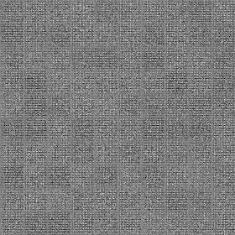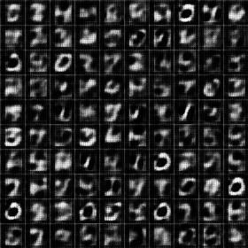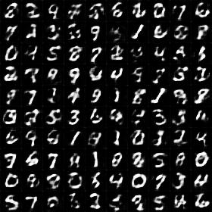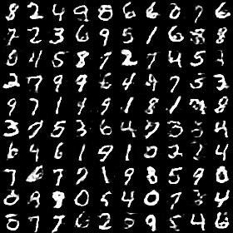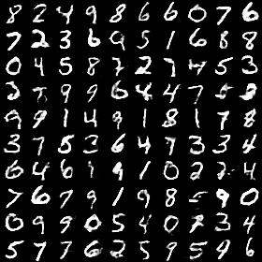

Figure 4.3.2 Generation of DCGAN at epoch 1, 2, 5, 20 and 50 at noise 0.2

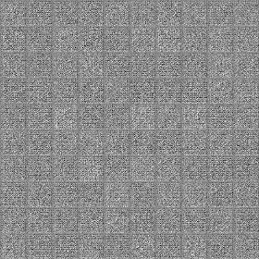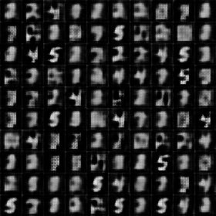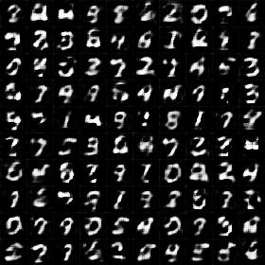



Figure 4.3.3 Generation of DCGAN at epoch 1, 18, 20, 40 and 50 at noise 0.4

## 4.4 Comparison with PCA

In order for us to access the performance of the dimension reduction for different methods proposed in this paper versus PCA (with 2 components), we will employ supervised classifier. From the given data we know the labels for the 55,000 different images in our dataset. These labels will be used for accuracy determination.

We take the original data and add the noise factors of 0.0 (no noise), 0.2 (20% of pixels with noise), and 0.4 (40% of pixels with noise) to it. Once this is completed, we perform dimension reduction on the data with the different models (RDA, RPCA, RVAE, PCA and Original data) as discussed above.

For evaluation we use value of L (low-rank component) for RPCA, the latent layer values for RDA and RVAE, the reduced dimension transformation obtained from PCA, and the original data. The reason we tested the original data and noise factor of 0.0 (no noise) is to set a baseline for dimension reduction models with multiple noise factors. To see if the accuracy would increase or decrease when we add more noise in each model. Next, we split 75-25% of the reduced data for training and testing and run them through Random Forest. The plot below shows the outcome of this analysis for 0, 20% and 40% noise addition to the MNIST dataset.

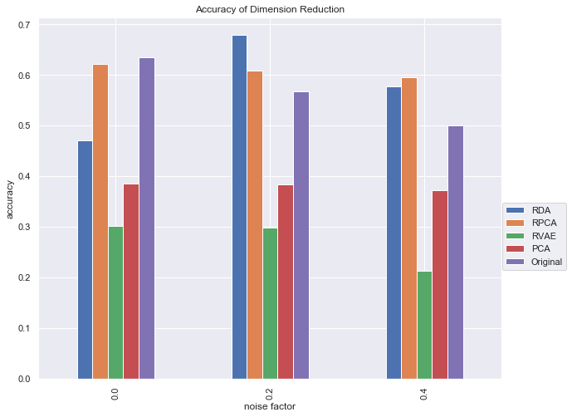

Figure 4.4.1 Accuracy of dimension reduction

We can observe from the plot that RDA performs best when there is 20% noise in the dataset but RPCA performs slightly better than RDA with 40% noise. PCA has a consistently bad performance as compared to the robust methodologies. When there is no noise in the data, the original data performs best but as the noise increased, RDA and RPCA perform better than the original one.

# 5. Conclusion

In conclusion, when we performed a side-by-side comparison of the generated images using the three methodologies as described in our paper we noticed that at the noise factor of 0.2 the images are much sharper as compared to the noise factor 0.4. In addition to this, upon visual inspection, the images generated using RVAE are significantly clearer and sharper as compared to DCGAN and RPCA + VAE and VAE methodologies. The comparison of different methods’ results is shown in Figure 5.1 and 5.2 with noise equal to 0.2 and 0.4 respectively.

RVAE is robust to reconstruct data from data corrupted by Gaussian noise. It gives us the best result so far. We are not surprised with the poor result of RPCA+VAE since RPCA has strict requirement for noise distribution. It’s only robust when the noise is sparse. However, as explained at the beginning of the paper, we added Gaussian noise for all of the experiments. Since DCGAN applied CNN as generator, it is clearly shown the CNN edge detection ability in our DCGAN generation result. Although the input image of DCGAN is corrupted, when there is less noise, DCGAN learns to generate the most real digital among all the experiments. ReLU function in the DCGAN model is regarded as dimension reduction and noise detection steps. It can handle different shape of digital as well as Gaussian noise in our data, although it does not learn the distribution of data very well.

Noise Factor = 0.2

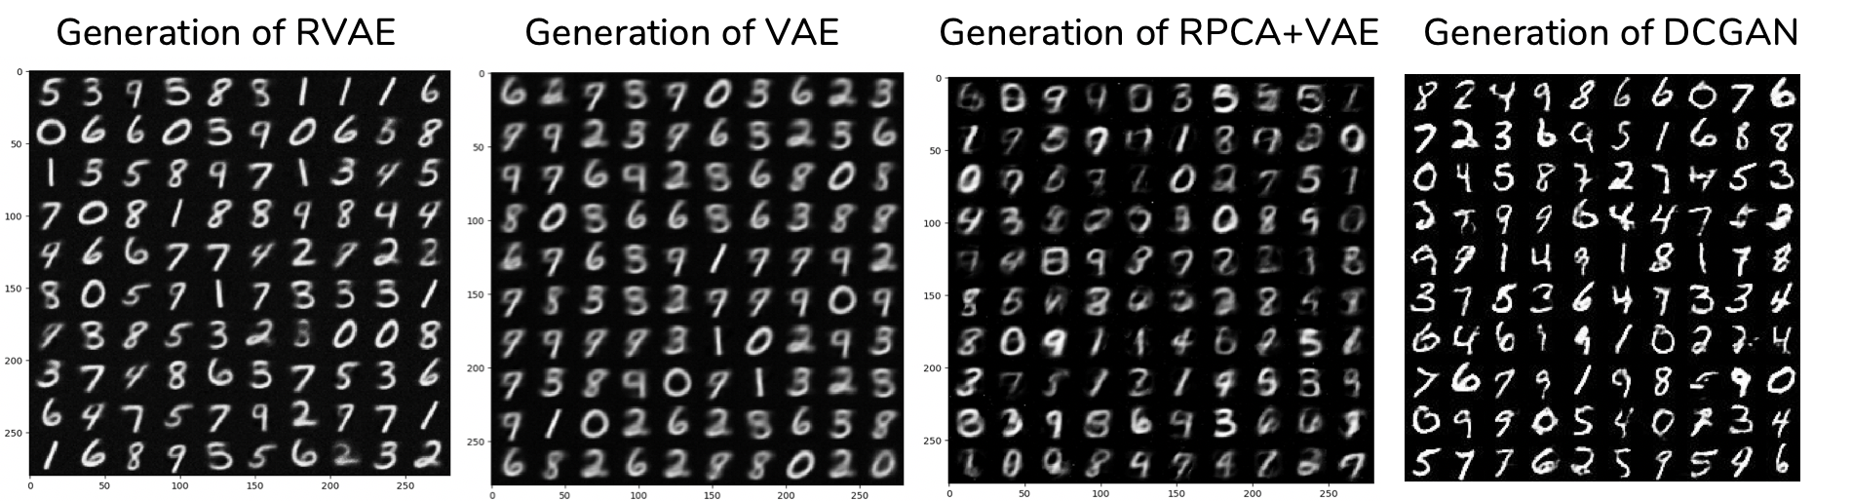

Figure 5.1 Generation of models at noise factor 0.2

Noise Factor = 0.4

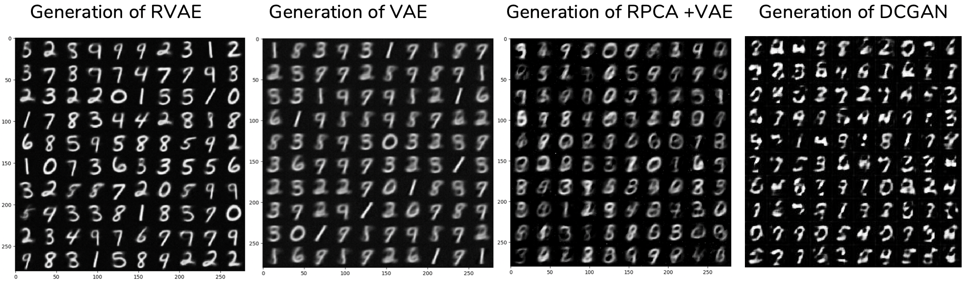

Figure 5.2 Generation of models at noise factor 0.4

Our next step is to analyze more detail of RVAE result as well as fine-tune the DCGAN. We are also interested in working on CNN+RVAE which is just replace encoding and decoding layers in VAE with CNN. We believe there are more work we could work on for this project to test different settings in the future.

# 6. References

Candès, Emmanuel J., et al. "Robust principal component analysis?" *Journal of the ACM (JACM) 58.3* (2011): 11.

Dertat, Arden. "Applied Deep Learning - Part 3: Autoencoders." 3 October 2017. *Towards Data Science.* https://towardsdatascience.com/applied-deep-learning-part-3-autoencoders-1c083af4d798. November 2018.

LeCun, Yann, Corinna Cortes and Christopher J.C. Burges. *The MNIST Database of handwritten digits*. n.d. http://yann.lecun.com/exdb/mnist/. November 2018.

Radford, Alec, Luke Metz and Soumith Chintala. "Unsupervised Representation Learning with Deep Convolutional Generative Adversarial Networks." *ICLR*. 2016. arXiv:1511.06434v2 [cs.LG].

Sun, Shao-Hua. *Variational Autoencoder in Tensorflow*. 30 September 2017. https://github.com/shaohua0116/VAE-Tensorflow/blob/master/demo.ipynb . November 2018.

TensorFlow. *TensorFlow*. n.d. https://www.tensorflow.org/ . November 2018.

Wikipedia. *Artificial Neural Networks*. n.d. https://en.wikipedia.org/wiki/Artificial_neural_network . 1 December 2018.

—. *Autoencoder*. n.d. https://en.wikipedia.org/wiki/Autoencoder. 1 December 2018.

WPI. *Turing Server*. n.d. http://arc.wpi.edu/computing/ . November 2018.

Zhou, Chong and Randy C Paffenroth. "Anomaly Detection with robust deep auto encoders." *Proceedings of the 23rd ACM SIGKDD International Conference on Knowledge Discovery and Data Mining*. ACM, 2017.